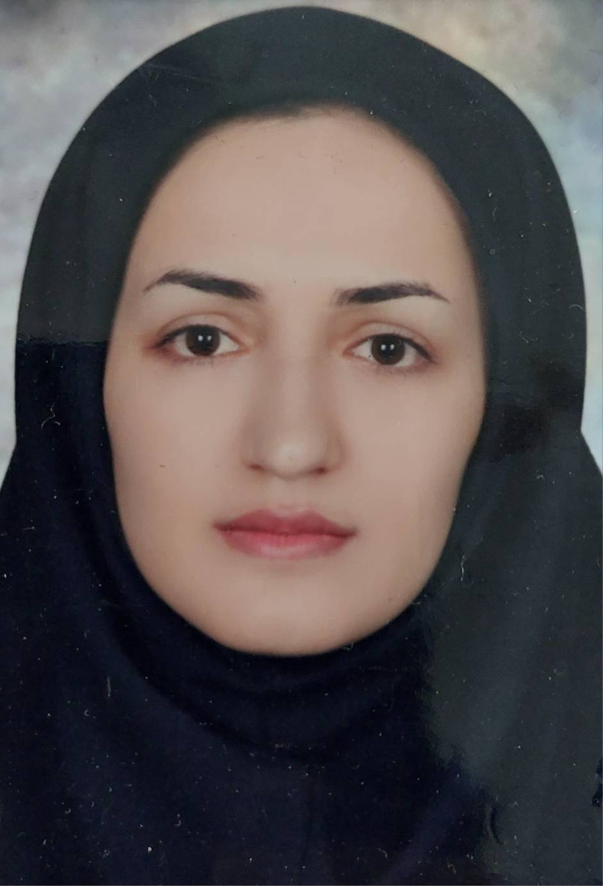  CONTACT  Address:  Ilam University of Medical Science, Faculty of Nursing & Midwifery, Ilam, Iran.  Email: :  pourmehdi-m@medilam.ac.ir |  | Current Position  Clinical Faculty Member  Education  ADDITIONAL SKILLS And Research Interests  - Clinical trials  - Qualitative research  - Quantitative research  - Systematic review and meta-analysis  - Mixed methods  - Education research  - Validity and reliability instruments  Thesis  - The effect of acupressure in two points ; Sanyingjiao (Sp6) and Taichong (Liv3) on improvement of women’s sexual function and quality of sexual life  Teachings  Scientificprofiles  Google scholar : https://scholar.google.com/citations?user=oa_MqjAAAAAJ&hl=en&oi=ao  Research Gate  https://www.researchgate.net/profile/Mehri-Pourmehdi  ORCID Page:  https://orcid.org/0009-0006-4831-8351  Publications  a. Articles  1. Pourmehdi M, Maasoumi R, Tayebi N, Sabetghadam S, Haeri-Mehrizi AA. The effect of acupressure at the Sp6 and Liv3 points on improving women’s sexual function and quality of sexual life: a randomized controlled trial. Iranian Journal of Obstetrics, Gynecology and Infertility. 2024;27(10):17-28.  2. Borchaloee AS, Zahmatkesh M, Toomary E, Bazzazbonabi N, Aghaei N, Ghavampour N, Pourmehdi M. EPIDEMIOLOGY AND PREVALENCE OF LISTERIA MONOCYTOGENES ABORTION: A SYSTEMATIC REVIEW. Turkish Journal of Physiotherapy and Rehabilitation.;32:3.  - Member of the Cultural Committee of the Faculty of Nursing and Midwifery
  Country | University | Grade
  Iran | Ilam university of medical science | BS of Midwifery
  Iran | Tehran University of Medical Science (TUMS) | MSc of Midwifery
  Year | Title of lesson | ** Type of lesson (theory or Practical) | * Level | School
  2024-2025 | Courses of Gynecology & obstetrics and Health | Theory or Practical | Undergraduate | Nursing& midwifery
Membership

